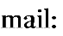
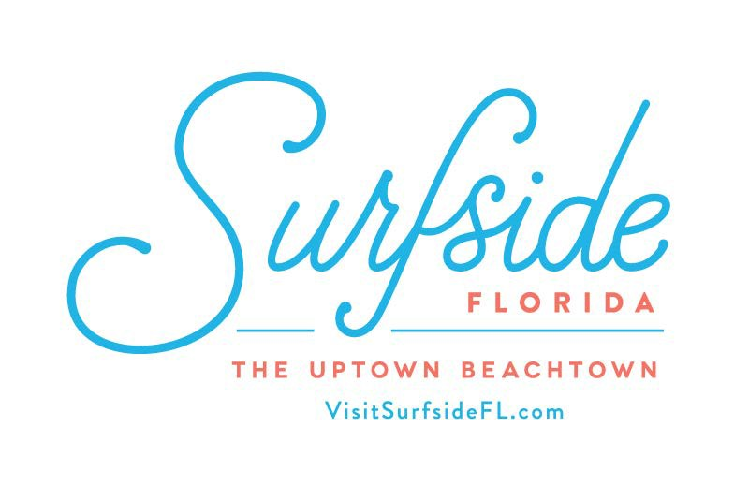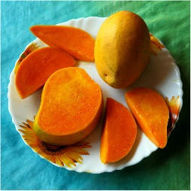
Please e-mail a completed form to Dalia Blumstein at daliablumstein@gmail.com and
drop off your mango sample Sunday, June 23 at the Community Center from 9 – 11 am.
The contest portion will be held at the Community Garden (89th Street & Dickens Ave.)
from 5 – 6 pm.

**Only Surfside Residents can enter. All mangoes for submission must be grown exclusively in Surfside.
Each mango will be judged in the following criteria:

- Taste: (20 points max)
- Aroma: (10 points max)
- Texture: (10 points max)

